Software Requirements Specification

for

SmartAgCloud

Version 1.0

Prepared by:

Priya Yadav

Jessica Mathias

Ankita Chikodi

Priya Khadke

San Jose State University

19th Feb 2019

Table of Contents

Table of Contents ii

Revision History iii

1. Introduction 1

1.1 Purpose 1

1.2 Intended Audience 1

1.3 Application Scope 1

2. Overall Description 2

2.1 Product Perspective 2

2.2 Product Functions 2

2.3 User Classes and Characteristics 3

2.5 Operating Environment 3

2.4 Design and Implementation Constraints 4

2.5 Assumptions and Dependencies 4

3. External Interface Requirements 4

3.1 User Interfaces 4

3.2 Hardware Interfaces 4

3.3 Software Interfaces 5

3.4 Communications Interfaces 5

4. System Features 6

4.1 User Registration 6

4.2 User Login 7

4.3 Build Smart Farm 8

4.4 Sensor Data Management 8

4.5 Cloud Based Sensor Data Management 9

4.6 View Ranch-based dashboard 10

4.7 View Cloud-based dashboard 10

4.8 Receive Alerts 11

5. Other Nonfunctional Requirements 12

5.1 Performance Requirements 12

5.2 Security Requirements 12

5.3 Software Quality Attributes 12

6. System infrastructure and architectures 12

7. System design and Component interaction design 14

8. Plan and schedule 15

9. Technology Selection 15

9.1 Cloud Provider 16

9.2 Back End Server Technology 16

9.3 MQTT 16

9.4 MySQL 16

9.5 Front-end JavaScript 16

9.6 Mobile App Android 16

9.7 Abbreviation 16

Revision History

|  |  |  |  |
| --- | --- | --- | --- |
| **Name** | **Date** | **Reason for Changes** | **Version** |
|  |  |  |  |
|  |  |  |  |

# Introduction

## Purpose

This document describes the system requirements specification for an IOT-based smart agriculture infrastructure service management system as a service on a cloud namely SmartAgCloud. The document describes in detail the requirements and high-level design of the application. The document includes the details on defining scope along with assumptions and dependencies. The IOT based application will be designed and implemented for ranch field farms.

The application supports a connected farm where soil and crop conditions across the ranch can be monitored by the farmer as per his needs. This is achieved by implementing a large-scale on-demand IOT-based agriculture system infrastructure services for farmers. Each farmer could select install and deploy one or more IOT agriculture networks for their ranch fields. The sensors used for monitoring the soil and crop conditions in the ranch communicate with the IOT system through a gateway. The IOT system processes the data and sends data to the farmer’s device in the form of notifications. The farmer can also see view the condition of his ranch using the designed dashboard. Using this data collected from the smart ranch could also help the farmer get intelligent agricultural solutions based on shared expert knowledge

## Intended Audience

This document is intended to be used by farmers, IoT managers, IoT supporters, business stakeholders, developers, architect and testers. This document can also be helpful for individual looking for smart farming solutions in agriculture domain. The document includes high level application understanding including product scope and functionality. It is recommended to follow the sections in order as presented by document to get high level understanding followed by low level details.

## Application Scope

SmartAgCloud is a cloud service solution for smart agriculture which helps farmers to monitor farms which are remotely located; thereby saving time and cost involved. The SmartAgCloud application is expected to achieve goals of implementing the solution on cloud and leverage the cloud benefits of OnDemand resource allocation, run time scaling, reduced cost, improved coverage. Below are the key features in scope for the SmartAgCloud.

1. Builds smart farm to monitor below parameters,

* Temperature,
* Humidity,
* Wind Speed
* Wind Direction
* Rain
* Measures Soil Moisture

The above parameters will be generated by simulated software. This software is expected to simulate below two real types of sensors,

* AcuRite
* Soil Moisture Meter Probe - 24 Inch

Out of Scope

Real sensors are out of scope of this application including the connectivity and setup configuration. Only data feeds will be simulated by software.

# Overall Description

### Product Perspective

Technologies and IoT have the potential to transform agriculture in many aspects. Namely, there are five ways IoT can improve agriculture:

Data, tons of data, collected by smart agriculture sensors, e.g. weather conditions, soil quality, crop’s growth progress or cattle health. This data can be used to track the state of your business in general, as well as staff performance, equipment efficiency, etc.

Better control over the internal processes and, as a result, lower production risks. The ability to foresee the output of your production allows you to plan for better product distribution. If you know exactly how much crops you are going to harvest, you can make sure your product won’t lie around unsold.

benefits-of-smart-farming

Cost management and waste reduction thanks to the increased control over production. Being able to see any anomalies in the crop growth or livestock health, you will be able to mitigate the risks of losing your yield.

Increased business efficiency through process automation. By using smart devices, you can automate multiple processes across your production cycle, e.g. irrigation, fertilizing, or pest control.

Enhanced product quality and volumes. Achieve better control over the production process and maintain higher standards of crop quality and growth capacity through automation.

As a result, all of these factors can eventually lead to higher revenue.

Now that we have outlined how IoT can be advantageously applied in the sphere of agriculture, let’s take a look at how the listed benefits can find their application in real life.

## Product Functions

Your ***SmartAgCloud*** is a IOT-based smart agriculture infrastructure service management system on a cloud to provide farmers with on-demand large-scale services in building their own IOT infrastructure networks by booking, configuration, installation, and deployment of desired IOT-based agriculture sensor networks in their ranches.

The key features of the application are stated below:

1. Monitors the agricultural conditions using data feed from smart sensors at real time
2. Allows farmers to configure smart ranch fields within farmlands.
3. Allows farmers to select their own desired ranches within farmland
4. Book the resources (different types of sensors) (sensor profile should include sensor type, name, value data type).
5. Dashboard on web and mobile facilitate real time monitoring
6. Receive notifications of monitored parameters on registered devices in real time.

## User Classes and Characteristics

SmartAgCloud is expected to have below 3 types of users

1. **Farmers** – The primary user of this application. Farmers can access the system to check and

configure their own IOT networks online by accessing SmartAgCloud to check their IOT sensor

status and statistic data,

1. **IOT Supports** – IOT support manager can access the system to the status of smart nodes and sensors.
2. **Infrastructure Managers** – The persons who setup, configure, and manage smart nodes, cluster nodes,

and sensors, as well as their connectivity. In addition, they could monitor and track the status of

smart nodes with diverse sensors.

## 

Fig 1: Use case diagram of the SmartAg system

## 2.5 Operating Environment

Linux: Open source OS which will be used to implement the backend of the SmartAg system

Android: Android studio is the software component used to build the mobile application

## Design and Implementation Constraints

It is not possible to use real sensors in the ranch due to time and cost constraints. Hence, we will be using simulation software to get real time sensor data

## Assumptions and Dependencies

The SmartAgCloud is primarily using cloud service by AWS. The cloud provider AWS

is thus a dependency for the SmartAgCloud to function.

The farmer should have internet connection in order to use the SmartAg application

# System Features

# 



## User Registration

|  |  |
| --- | --- |
| **Use case:** User Registration | |
| **Actors:** Farmer/IoT Manager /Infrastructure Manager | |
| **Purpose: Register a user in SmartAgCloud Application** | |
| **Overview: Allows users to register in SmartAgCloud and assign respective roles to the users** | |
| **Type: Essential** | |
| **Preconditions**: NA | |
| **Postconditions:** The user must be able to register to the SmartAgCloud application via web or mobile  App and appropriate role must be assigned. | |
| **Special Requirements: NA** | |
| **Flow of Events** | |
| **Actor Action** | **System Response** |
| 1. This use case begins after the new user opens the SmartAgCloud site or mobile application and selects Register User option 2. Users fills in the registration form and registers to the system. | 1. System prompts the new user registration form.  2. The application will save the user details and assigns  appropriate roles (from Farmer/IoT Manager /  Infrastructure Manager) to the user. |
| 1. **Alternative Flow of Events** |  |
| Line 1: If the user is already registered, the user can login to the application by selecting login option. | |

## User Login

|  |  |
| --- | --- |
| **Use case:** User Login | |
| **Actors:** Farmer/IoT Manager /Infrastructure Manager | |
| **Purpose: Logins a user in SmartAgCloud Application** | |
| **Overview: Allows users to login in SmartAgCloud and use application as per assigned role** | |
| **Type: Essential** | |
| **Preconditions**: The user must be registered in the application | |
| **Postconditions:** The user must be able to login to the SmartAgCloud application via web or mobile  App and appropriate role must be assigned. | |
| **Special Requirements: NA** | |
| **Flow of Events** | |
| **Actor Action** | **System Response** |
| 1. This use case begins after the new user opens the SmartAgCloud site or mobile application and selects Login option 2. Users enters the username and password and logins to the system. | 1. Application prompts the to enter username and password.  2. The application will authenticate the user details, and  Displays the home page. |
| 1. **Alternative Flow of Events** |  |
| Line 1: if username/password is invalid, return error message "Invalid username/password" to Output  and terminate this Use Case. | |

## Build Smart Farm

|  |  |
| --- | --- |
| **Use case:** Build smart farm | |
| **Actors:** Infrastructure Managers | |
| **Purpose:** Build smart farms to enable monitoring via sensors within selected farm areas | |
| **Overview: Allows *Infrastructure Managers* to build the one or more smart ranches within his**  **farm with farmers choice of sensors** | |
| **Type: Essential** | |
| **Preconditions**: The users are registered in SmartAgCloud application as an Infrastructure Managers | |
| **Postconditions:** The smart farm is setup by Infrastructure Managers by the choice of farmer is able to view  the selected farms in the dashboard | |
| **Special Requirements:**   1. ***Cluster node management*** – It allows Infrastructure Managers to add/update/delete/view cluster nodes for an agriculture IOT sensor network, and track cluster node status. 2. ***Smart node management –*** It allows Infrastructure Managers to add/update/delete/view smart nodes   controlled by a cluster, and track node status. | |
| **Flow of Events** | |
| **Actor Action** | **System Response** |
| 1. This use case begins after the Infrastructure Managers logins to the SmartAgCloud application with his username and password and selects Build Smart Farm option 2. Infrastructure Managers selects one ranch at a time from the provided farm map and then selects the smart sensors and required numbers of sensors 3. Infrastructure Managers may choose to build multiple unique ranches within this use case | 1. Verify the entered username and password   and allow user to login on authentication.   1. Triggers request to IoT managers to deploy and   validate the connections of the sensors. Display the selected smart ranch details and smart sensors details on farmers profile. |
| 1. **Alternative Flow of Events** |  |
| Line 1: if username/password is invalid, return error message "Invalid username/password" to Output  and terminate this Use Case. | |

## Sensor Data Management

|  |  |
| --- | --- |
| **Use case:** Sensor Data Management | |
| **Actors:** IOT Manager | |
| **Purpose:** To allow managers to manage the sensors data and connectivity. | |
| **Overview: Allows IoT manager to update sensors data reading, sensor’s profile and retrieve**  **sensors data for a specified time interval** | |
| **Type: Essential** | |
| **Preconditions**: The user is registered in SmartAgCloud application with IoT manager role | |
| **Postconditions:** The IOT agricultural data manager is able to update sensors data reading, add/delete/  update the sensor’s profile and retrieve the sensor’s data. The updated sensor profile is available for  farmers to build the smart farm. | |
| **Special Requirements:** none | |
| **Flow of Events** | |
| **Actor Action** | **System Response** |
| 1. This use case begins after the farmer logins to the SmartAgCloud application with his username and password and selects Build Smart Farm option 2. Farmer selects one ranch at a time from the provided farm map and then selects the smart sensors and required numbers of sensors 3. Farmer may choose to build multiple unique ranches within this use case | 1. Verify the entered username and password and  allow user to login on authentication.  2. Display the selected smart ranch details and smart c  Sensors details on farmers profile. |
| 1. **Alternative Flow of Events** |  |
| Line 1: if username/password is invalid, return error message "Invalid username/password" to Output  and terminate this Use Case. | |

## Cloud Based Sensor Data Management

|  |  |
| --- | --- |
| **Use case:** Cloud-based sensor data management | |
| **Actors:** An IOT agriculture data manager | |
| **Purpose:** To allow managers to manage the sensors data and connectivity. | |
| **Overview: Allows IoT manager to update sensors data reading, sensor’s profile and retrieve**  **sensors data for a specified time interval** | |
| **Type: Essential** | |
| **Preconditions**: The user is registered in SmartAgCloud application with IoT manager role | |
| **Postconditions:** The IOT agricultural data manager is able to update sensors data reading, add/delete/  update the sensor’s profile and retrieve the sensor’s data. The updated sensor profile is available for  farmers to build the smart farm. | |
| **Special Requirements:** none | |
| **Flow of Events** | |
| **Actor Action** | **System Response** |
| 1. This use case begins after the farmer logins to the SmartAgCloud application with his username and password and selects Build Smart Farm option 2. Farmer selects one ranch at a time from the provided farm map and then selects the smart sensors and required numbers of sensors 3. Farmer may choose to build multiple unique ranches within this use case | 1. Verify the entered username and password and  allow user to login on authentication.  2. Display the selected smart ranch details and smart c  Sensors details on farmers profile. |
| 1. **Alternative Flow of Events** |  |
| Line 1: if username/password is invalid, return error message "Invalid username/password" to Output  and terminate this Use Case. | |

## View Ranch-based dashboard

|  |  |
| --- | --- |
| **Use case: View ranch-based dashboard of the monitored smart farm** | |
| **Actors:** Farmer/IoT Manager | |
| **Purpose:** To allow farmers to view real time status of monitored smart field via dashboard on Mobile app  Or web interface | |
| **Overview: Allows farmers to view ranch-based dashboard via mobile app or online interface** | |
| **Type: Essential** | |
| **Preconditions**: The user is registered in SmartAgCloud application with farmer role | |
| **Postconditions:** The farmer is able to view ranch-based dashboard for all built smart farms. | |
| **Special Requirements:** none | |
| **Flow of Events** | |
| **Actor Action** | **System Response** |
| 1. This use case begins after the farmer logins to the SmartAgCloud application with his username and password  2. Farmer selects view dashboard option.  3. Farmer selects a ranch to monitor | 1. Verify the entered username and password and   allow user to login on authentication.   1. Displays the dashboard for logged in farmer’s   profile   1. Displays the farm stats for the set period of interval the selected |
| **Alternative Flow of Events** | |
| Line 1: if username/password is invalid, return error message "Invalid username/password" to Output  and terminate this Use Case.  Line 2: Farmer may edit the default the time duration for the dashboard; the system will display the stats  As per edited duration. | |

## View Cloud-based dashboard

|  |  |
| --- | --- |
| **Use case: View Cloud-based dashboard of the monitored smart farm** | |
| **Actors:** Infrastructure /IoT Manager | |
| **Purpose:** To allow Infrastructure /IoT Manager to view real time status of all monitored smart field via  dashboard on Mobile app Or web interface | |
| **Overview: Allows** Infrastructure /IoT Manager **to view cloud-based dashboard via mobile app or**  **web interface** | |
| **Type: Essential** | |
| **Preconditions**: The user is registered in SmartAgCloud application with Infrastructure /IoT Manager role | |
| **Postconditions:** The Infrastructure /IoT Manager is able to view ranch-based dashboard for all  built smart farms and devices | |
| **Special Requirements:** none | |
| **Flow of Events** | |
| **Actor Action** | **System Response** |
| 1. This use case begins after the user logins to the SmartAgCloud application with his username and password  2. user selects view dashboard option.  3. user selects a ranch to monitor | 1. Verify the entered username and password and   allow user to login on authentication.   1. Displays the dashboard for logged in user   profile   1. Displays the farm stats for the set period of interval the selected |
| **Alternative Flow of Events** | |
| Line 1: if username/password is invalid, return error message "Invalid username/password" to Output  and terminate this Use Case.  Line 2: user may edit the default the time duration for the dashboard; the system will display the stats  As per edited duration. | |

## Receive Alerts

|  |  |
| --- | --- |
| **Use case: Receive alerts on monitored** | |
| **Actors:** Farmer /IoT Manager | |
| **Purpose:** Notify Farmer/Infrastructure Managers of any action required  on all monitored smart field via dashboard on Mobile app or web interface | |
| **Overview: Allows Infrastructure /IoT Manager to receive alerts on monitored smart farms in case**  **of emergency** | |
| **Type: Essential** | |
| **Preconditions**: The smart farm must be monitored, and users must be registered as farmers/IOT manager | |
| **Postconditions:** Farmers/IoT Managers are notified of any action required or monitored  parameter crossing minimum/maximum threshold | |
| **Special Requirements:** none | |
| **Flow of Events** | |
| **Actor Action** | **System Response** |
| 1. This use case begins after the user logins to the SmartAgCloud application with his username and password  2. user selects view dashboard option.  3. user selects a ranch to monitor | 1. Verify the entered username and password and    1. allow user to login on authentication. 2. Displays the dashboard for logged in user    1. profile 3. Displays the farm stats for the set period of interval the selected |
| **Alternative Flow of Events** | |
| Line 1: if username/password is invalid, return error message "Invalid username/password" to Output  and terminate this Use Case.  Line 2: user may edit the default the time duration for the dashboard; the system will display the stats  As per edited duration. | |

# Other Nonfunctional Requirements

## Performance Requirements

The SmartAgCloud application is expected to give real-time or near to real-time data feed from IOT devices – software sensors. The online transaction is expected to not exceed 10 secs.

## Security Requirements

The SmartAgCloud application should strictly adhere to user privacy by implementing features specific to user roles. SmartAgCloud will use secure protocol HTTPS communication for communication over the internet. Registered users with secure login will be enabled to take appropriate actions.

## Software Quality Attributes

Usability: The SmartAgCloud interface should be easy to understand for the primary user – farmer. This will be achieved using simple and easy layout of GUI.

Reliability/Availability: The application is expected to 99.99% available to the end user.

Scalability: The application should be able to sustain and dynamically handle the surge in traffic without affecting the application performance. The application should be able to scale horizontally in real time to serve any increase in traffic.

Extensibility: The application should be adaptive to the future changes with minimal changes within application design or interface.

# System infrastructure and architectures

The overview of our SmartAgCloud architecture consists of 2 components namely cloud infrastructure and entities.

The three entities are farmer, IOT supports and IT Infrastructure manager

1. Farmer: They access the system to get updates and notifications about SmartAgCloud through the dashboard
2. IOT Supports:They monitor the status of smart nodes and sensors through the customized dashboard
3. Infrastructure Managers – They register/manage smart sensor nodes for the system through the dashboard

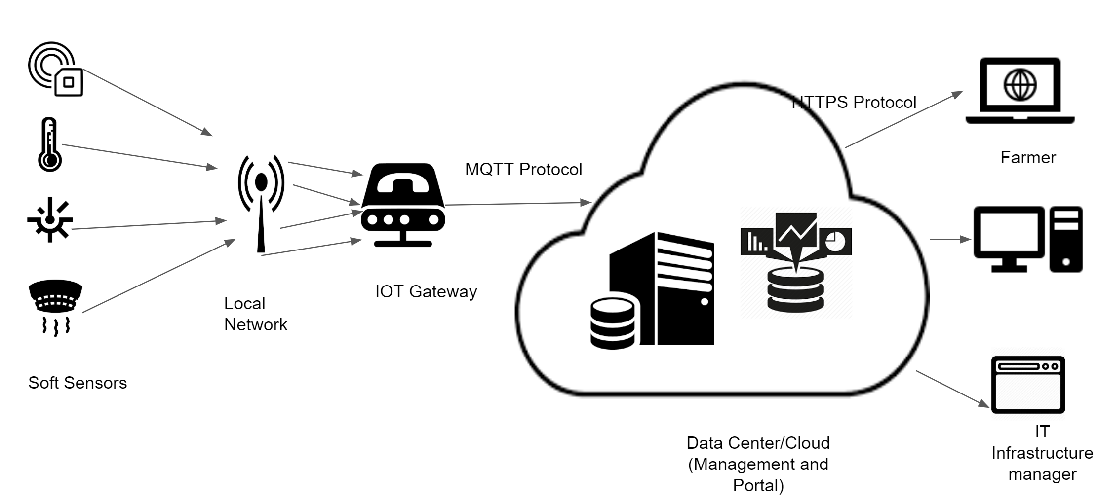

# 

# System design and Component interaction design

The cloud infrastructure consists of components such as simulation software, application server, management server, portal server and a database.

1. Simulation software for Sensors: This software simulates the data generated by various sensors in the network at real time and passes it on to the cloud database
2. Databases: The database used here is the MySQL DB which is a part of the AWS IOT infrastructure. The sensor data sent from the simulation software is handled by the application server which then stores it in the Database. Whenever there is a request from the entities or notification to be sent to the entities, the application server hits the database, retrieves the information and sends it across to the management server and portal server
3. Management server: The management server handles load balancing when there is increased demand for sensor data information, resource pooling and scalability (addition and deletion of sensors based on the farmers needs)
4. Portal Server: The portal server consists of the dashboard and user authentication. The farmer, IOT support or IOT Manager can access the application through the dashboard and customize their dashboard as per their needs

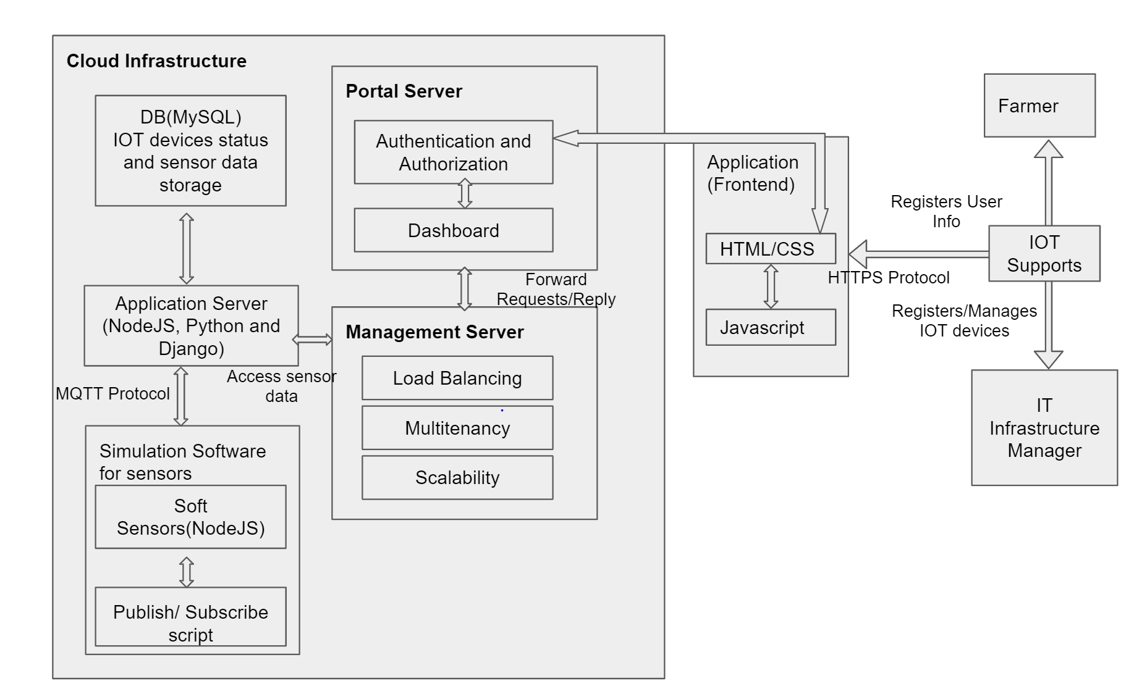

Fig : Black-box component design with API and functional description

## Database Design

High-level schemas and DB design is shared below. Two DB schemas are identified based on the type of data stored. Schema – Sensor is expected to get the data feeds from the soft sensors, while schema user is expected to contain the meta data to manage the smart agriculture application. These schemas should be on cloud infrastructure to support large scale sensors data feed demands.

## 

## Simulation Software Design

The agriculture sensors simulation would be designed using NodeJS backend. All the data communications thus would be in RESTful call /JSON format.

The simulation software is expected to contain below subcomponents:

1. Smart Sensors:
   * + Sensor data generator – This refers to the function that generates the simulated sensor’s data.

Sensor data collector – This will collect sensor data from different sensors based on a-predefined

schedule.

* + - Sensor data transfer – This refers to the function that transfer sensor data the back-end server on a

cloud.

* + - Smart node control – This refers to the basic control functions, such as node creation, update, deletion

as well as status change.

* + - Smart node configuration –This supports the configuration of a smart node, including

add/delete/update/set-up a list of sensors. For each sensor, it has the following status:

Turn-On, Active, Inactive, Turn-Off, and Maintenance

1. Smart Clusters:

A cluster node, which supports the controls and connectivity with other related nodes (required)

This controls and supports a number of smart nodes, and collect sensor data from them, and send sensor

data to the back-end server.

## 

# Plan and schedule

The below PERT chart describes the high-level planning and task breakdown overview that will be followed throughout the project lifecycle. The project will be delivered in phases in below order,

1. Initiation
2. Project Design and Analysis
3. Project Implementation
4. Final Submission

# 

# Technology Selection

The below section describes cloud technology selection, usage and validation environments

|  |  |  |
| --- | --- | --- |
| **Technology** | **Name** | **Remarks** |
| Language | NodeJS, Java, SQL, Python | Programming language |
| Communication Protocol | MQTT, HTTPS | To get data from devices |
| UI | HTML, CSS, JS | Web and mobile interface |
| DB | MySQL | To store and retrieve sensor data |
| MQTT Broker | Mosquitto | Broker to support devices on MQTT Protocol |
| Cloud | AWS | To build cloud infrastructure |
| Sensor Simulation | NodeJS | Soft sensors to generate, collect and transfer sensor data to the SmartAg cloud |
| Mobile App Development | Android Dev Studio | To build the android mobile app |
| Framework | NodeRed | Used for dashboard implementation |

## Cloud Provider

SmartAgCloud application is a solution on cloud, for which AWS (Amazon Web Service) compute service will be leveraged. AWS offers good range of instances. AWS will also provide the real time scaling of configured instances and backend with dynamic change in traffic using application load balancer.

## MQTT

The SmartAgCloud application is expected to give real-time or near to real-time data feed from IOT devices – software sensors. This requirement is expected to be fulfilled using the MQTT data bus transfer

MQTT offers below benefits,

1. MQTT has good integration with NodeJS (the backend logic)
2. MQTT is performance efficient where the monitored data is received with minimal connections

## 

## Abbreviation

|  |  |  |
| --- | --- | --- |
| **Sr No** | **Acronyms** | **Description** |
| 1 | MQTT | Message Queuing Telemetry Transport |
| 2 | AWS | Amazon Web Services |
| 3 | GUI | Graphical User Interface |
| 4 | PERT | Program Evaluation Review Technique |